

PHOTO
Position Applied for: |  |  |  |  | RPA Developerr
PERSONAL DATA
Name:  Bharti |  |  |  |  |  |  |  |  |  |  |  |  |  |  |  |  | Dubey
 |  | (First) |  |  |  |  |  |  |  |  |  | (Middle) |  |  |  |  |  | (Last)
*** as it appears in any of your ID Proof - Voter ID Card or Passport
Date of Birth: |  |  |  | 06/02/1995 |  |  |  | Gender: |  |  |  |  |  |  |  |  |  |  |  |  |  | Female
Marital Status: |  |  |  | Unmarried |  |  |  | Nationality: |  |  |  |  |  |  |  |  |  |  |  |  |  | Indian
Present Address |  |  |  |  | MIG A 218 Mukherjee Nagar, Vidisha
City: |  |  |  |  | Vidisha |  |  |  |  | State: |  |  | M.P. |  | Pin : |  |  |  |  |  | 464001
Telephone : ( ) |  |  |  |  |  |  |  |  |  | Mobile: |  |  | 8871456291 |  | Alternate No.: |  |  |  |  |  | 9425432074
E-Mail: |  |  |  |  | Bharti6294dubey@gmail.com
Permanent Address |  |  |  |  | MIG A 218 Mukherjee Nagar, Vidisha
City: |  |  |  |  | Vidisha |  |  |  |  | State: |  |  | M.P. |  | Pin : |  |  |  |  | 464001
Telephone : ( ) |  |  |  |  |  |  |  |  |  | Mobile: |  |  | 8871456291
 |  | EDUCATION DETAILS
Course |  |  | Degree and Specialization |  |  | Institute |  |  | University Name & Address |  |  |  |  | From (dd/mm/yyyy) |  | To (dd/mm/yyyy) |  |  | Completed |  |  |  | Program | Percentage
Std. X |  |  | All |  |  | SSR School Vidisha |  |  | M.P. Board |  |  |  |  | 2009 |  | 2010 |  |  | Yes |  |  |  | Part Time | 72%
 |  |  |  |  |  |  |  |  |  |  |  |  |  |  |  |  |  |  | No |  |  |  | Full Time
Std. XII |  |  | Maths |  |  | SSR School, Vidisha |  |  | M.P. Board |  |  |  |  | 2011 |  | 2012 |  |  | Yes |  |  |  | Part Time | 81%
 |  |  |  |  |  |  |  |  |  |  |  |  |  |  |  |  |  |  | No |  |  |  | Full Time
Graduation |  |  | B.TECH |  |  | LNCT Group Bhopal |  |  | RGPV |  |  |  |  | 2012 |  | 2016 |  |  | Yes |  |  |  | Part Time | 80%
 |  |  |  |  |  |  |  |  |  |  |  |  |  |  |  |  |  |  | No |  |  |  | Full Time
Post Graduation |  |  |  |  |  |  |  |  |  |  |  |  |  |  |  |  |  |  | Yes |  |  |  | Part Time
 |  |  |  |  |  |  |  |  |  |  |  |  |  |  |  |  |  |  | No |  |  |  | Full Time

EMPLOYMENT DETAILS
Kindly fill out the EXACT Details for your complete employment history. Please indicate any gaps/breaks during your employment with reasons. Please start with your most recent employment.
Tenure  From – To  (08/16)-  (04/19) | Organization details |  | Work Details:
Tenure  From – To  (08/16)-  (04/19) | Name: | Cognizant | Designation | RPA Developer
Tenure  From – To  (08/16)-  (04/19) |  |  | Employee No .605585
Tenure  From – To  (08/16)-  (04/19) | Address: | Coimbatore, Chennai, Banglore | Last Drawn Salary(p.a.) |  | April 2019
Tenure  From – To  (08/16)-  (04/19) |  |  | Reason for Leaving - Better career opportunity
Tenure  From – To  (04/19)-  (11/19) | Organization details |  | Work Details:
Tenure  From – To  (04/19)-  (11/19) | Name: | Techmahindra | Designation | Sr. RPA Software engineer
Tenure  From – To  (04/19)-  (11/19) |  |  | Employee No. 634681
Tenure  From – To  (04/19)-  (11/19) | Address: | Chennai | Last Drawn Salary(p.a.) |  | Oct 2019
Tenure  From – To  (04/19)-  (11/19) |  |  | Reason for Leaving - Better career opportunity
Tenure  From – To  (11/19)- Current | Organization details |  | Work Details:
Tenure  From – To  (11/19)- Current | Name: | Netlink | Designation | Sr. RPA Consultant
Tenure  From – To  (11/19)- Current |  |  | Employee No. 3699
Tenure  From – To  (11/19)- Current | Address: | Bhopal | Last Drawn Salary(p.a.) |  | Current
Tenure  From – To  (11/19)- Current |  |  | Reason for Leaving - Better career opportunity
Tenure  From – To  (mm/yy) | Organization details |  | Work Details:
Tenure  From – To  (mm/yy) | Name: |  | Designation
Tenure  From – To  (mm/yy) |  |  | Employee No.
Tenure  From – To  (mm/yy) | Address: |  | Last Drawn Salary(p.a.)
Tenure  From – To  (mm/yy) |  |  | Reason for Leaving
Tenure  From – To  (mm/yy) | Organization details |  | Work Details:
Tenure  From – To  (mm/yy) | Name: |  | Designation
Tenure  From – To  (mm/yy) |  |  | Employee No.
Tenure  From – To  (mm/yy) | Address: |  | Last Drawn Salary(p.a.)
Tenure  From – To  (mm/yy) |  |  | Reason for Leaving
FAMILY DETAILS
NAME OF FAMILY MEMBERS | Relationship | Occupation
Abdhesh Dubey | Father | Business
Guddi Dubey | Mother | Housemaker
Prashant Dubey | Brother | Graduation

CERTIFICATION / PROFESSIONAL MEMBERSHIP

Name | Type and status
UiPath | Certified
Automation Anywhere | Certified

HOBBIES
Traveling
Cooking

MEDICAL HISTORY
Self | NA |  |  |  |  | Spouse |  |  |  |  |  |  |  |  |  |  |  |  | Children
Do You Know anybody in IRIS?
No
Have you ever participated in any coding competition (or familiar with) – Techgig,Stackoverflow or any other ?

No
Events Planned in the next 6 months:
Wedding : |  | NO | Operation/Recovery : |  |  |  |  |  |  |  |  |  |  |  | NO |  |  |  |  |  |  |  | Other : |  |  |  |  |  |  | NO
Do you have a Passport |  |  | : |  |  | Yes / No |  |  |  |  | Valid Till |  |  |  |  |  |  |  |  | : |  |  |  |  | 2026
(If No, I will apply for a new / renewal of passport within 30 days of the date of offer with IRIS and submit the documentary proof of it).
Have you ever applied for Visa |  |  | : |  |  | Yes / No
 |  |  | If Yes, |  |  |  | Visa |  |  |  |  |  | Country |  |  |  |  |  |  |  |  |  |  | When |  |  |  |  | Valid Till
 |  |  |  |  |  |  | Visa |  |  |  |  |  | Country |  |  |  |  |  |  |  |  |  |  | When |  |  |  |  | Valid Till
Are there any Visa Rejections / Pending petition on your Passport :
 |  |  |  |  |  | If Yes, provide details :
Have you traveled overseas |  |  | : |  | Yes / No
 |  |  |  |  | If Yes, |  | Country |  |  |  |  |  |  |  |  | Period (from) |  |  |  |  |  |  |  |  |  |  | (to) |  |  |  | Visa
 |  |  |  |  |  |  | Country |  |  |  |  |  |  |  |  | Period (from) |  |  |  |  |  |  |  |  |  |  | (to) |  |  |  | Visa
Do you have a driving license |  |  | : | Yes / No (Two Wheeler / Four Wheeler/ Both ) Both
(If No, I will apply for a new / renewal of Car Driving License within 30 days of the date of offer with IRIS and submit the documentary proof of it).
Own Conveyance |  |  | : | Yes / No |  |  |  |  |  |  |  |  |  | What
Expected CTC |  |  | : | 16 LPA Fixed
Joining Time Required |  |  | : | 1 Month

Information Release Authorization
- I certify that the statements made in this application are valid and complete to the best of my knowledge. I understand that false or misleading information may result in termination of employment.
- If upon investigation, any of this information is found to be incomplete or inaccurate, I understand that I will be subject to dismissal at any time during my employment.
- I hereby authorize IRIS and/or any of its subsidiaries or affiliates, and any persons or organization acting on its behalf to verify the information presented on this application form (i.e. my educational, employment, residential details or others as required by IRIS) and to procure an investigation report or consumer report for that purpose.
- I hereby grant authority for the bearer to access or to be provided with full details of my previous record. In addition, please provide any other pertinent information requested by the individual presenting this authority.
- I hereby release from liability all persons or entities requesting or supplying such information.
- I authorize to contact my present and past employer.
- I have read, understand, and by my signature consent to these statements.
- All proprietary and confidential information shared with me by IRIS in verbal, written, electronic or any other physical form during the pre-employment stage will be safeguarded and will not be divulged to any third party.
Signature: 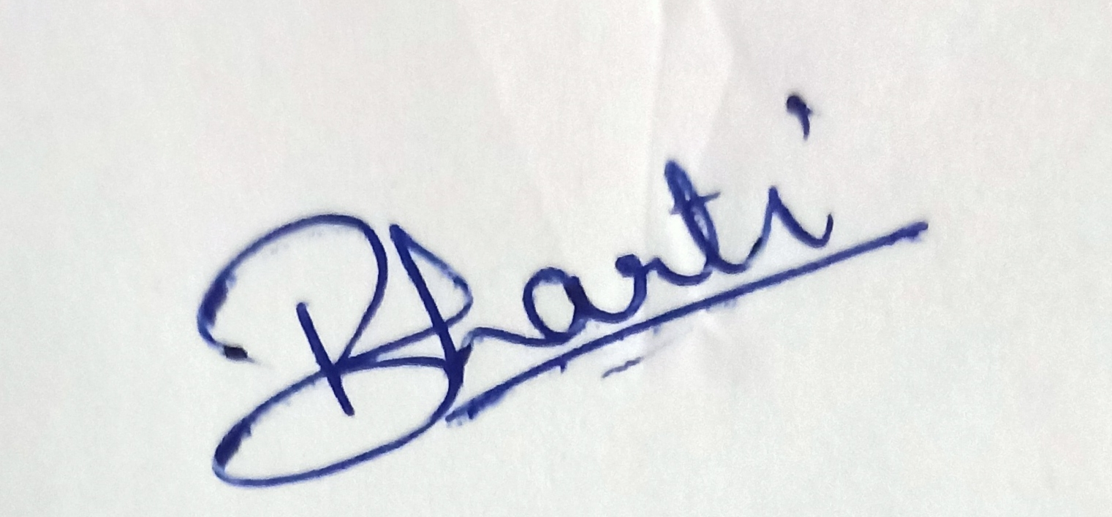  Name: Bharti Dubey |  |  |  |  |  |  |  |  |  |  |  |  |  |  |  |  |  |  |  |  | Date: 31/05/2021  Place : Vidisha

